**Online E-commerce System**

**Business overview:**

E-commerce also known as Electronic commerce is the most useful business over the internet.it refers to buy and sell of good products on global scale. This project deals with an e-commerce website for online shopping system. The Online Shopping System is a web based application for an existing shop. The main thing of the Online Shopping System is to manage all the information about shopping, products and customers. It would help to easily searching, viewing and selection of a product in any shop through internet by using android device. Customer can get the services without going to the market. This system provides a cart to a customer and customer can add a product to the shopping cart. It is easily accessible and always available.

**Project Summary**

Online Shopping System is a virtual store where the customers buy the product of interest. The Customers can search the details of products easily and select the product from different catalogue. The selected product may be collected in shopping cart. Customers can add a product to cart for purchase or delete a product from cart before selecting the final submission. After giving order, the product will deliver to the customer via Post office or currier services. Customer can also view products review and comment out their own review. A customer must have to be registered if they want to buy something. Every customer have a separate identity .Online shop has so many products. The products have to be identified as product type. Sometimes customer got commission by selling a fixed amount.Online Shopping System is not really much complicated.But sometimes the system can get much more complicated if it is not organized properly.

**ER diagram:**

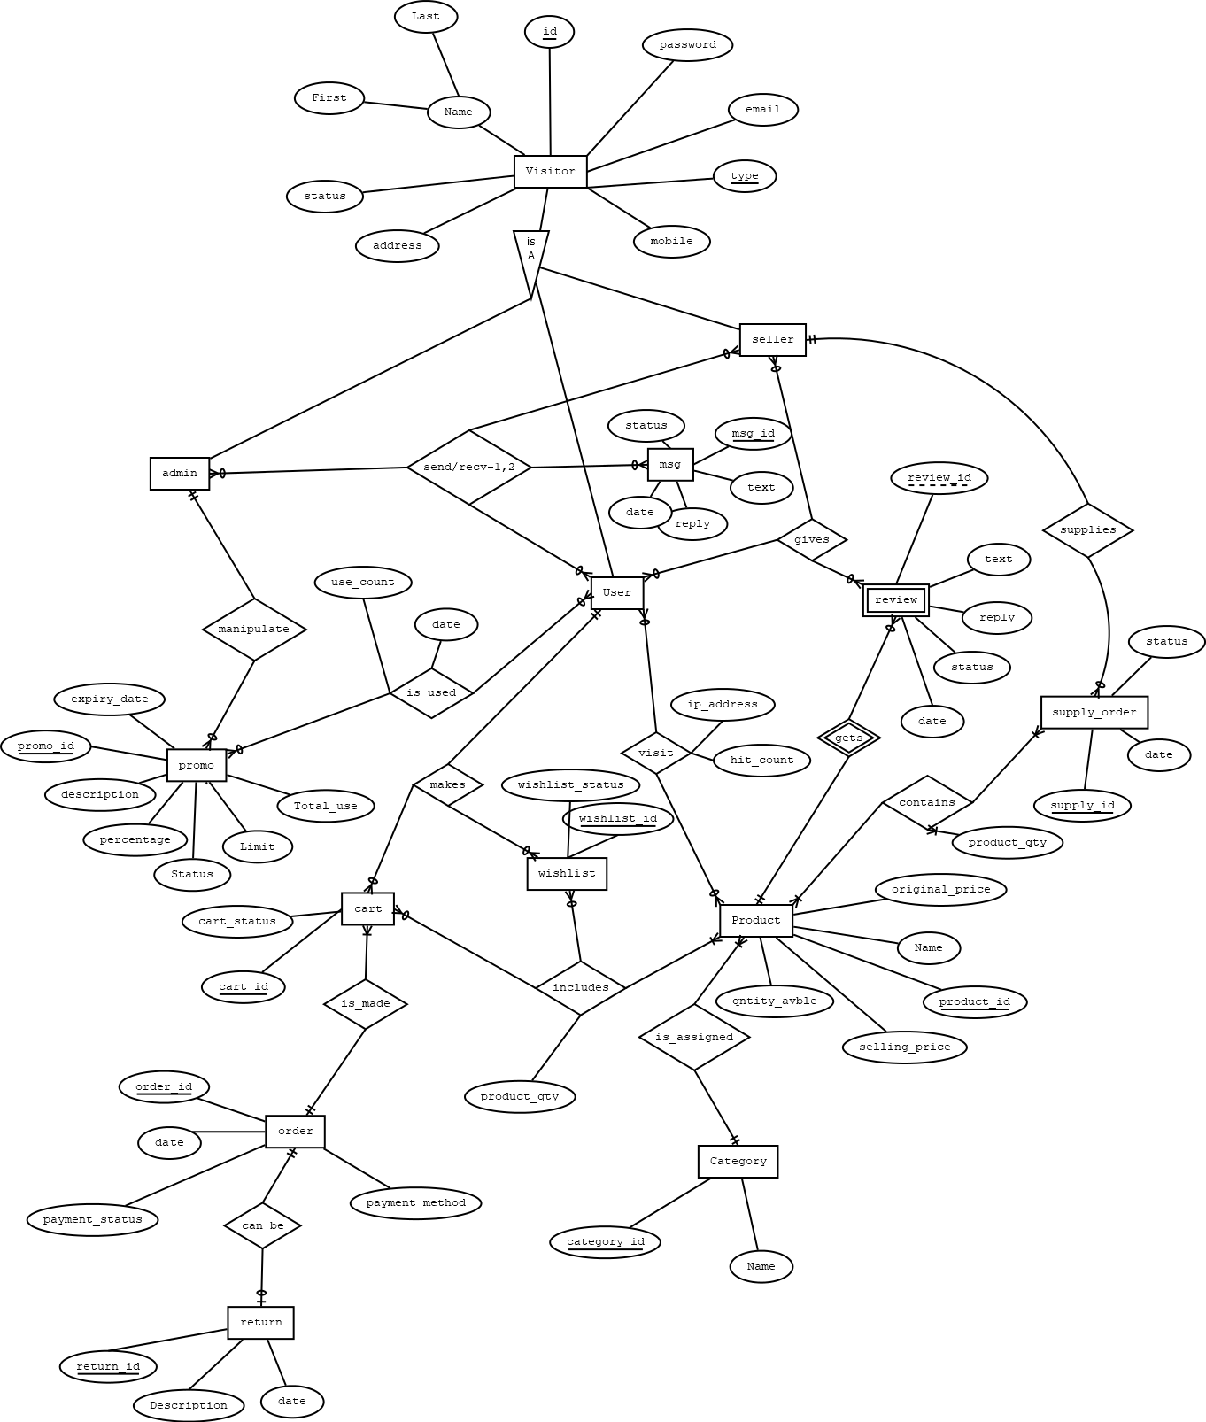

**Class diagram:**

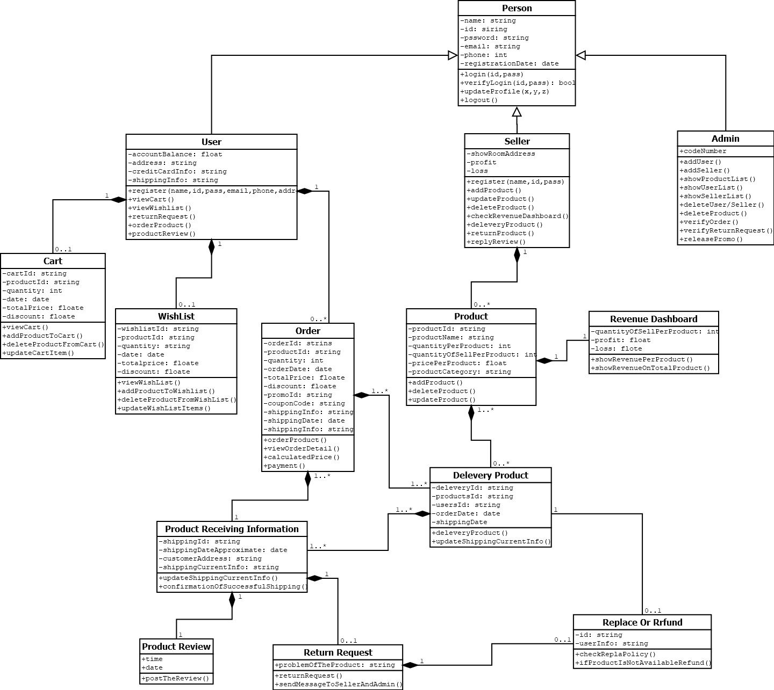

**Use-Case diagram:**

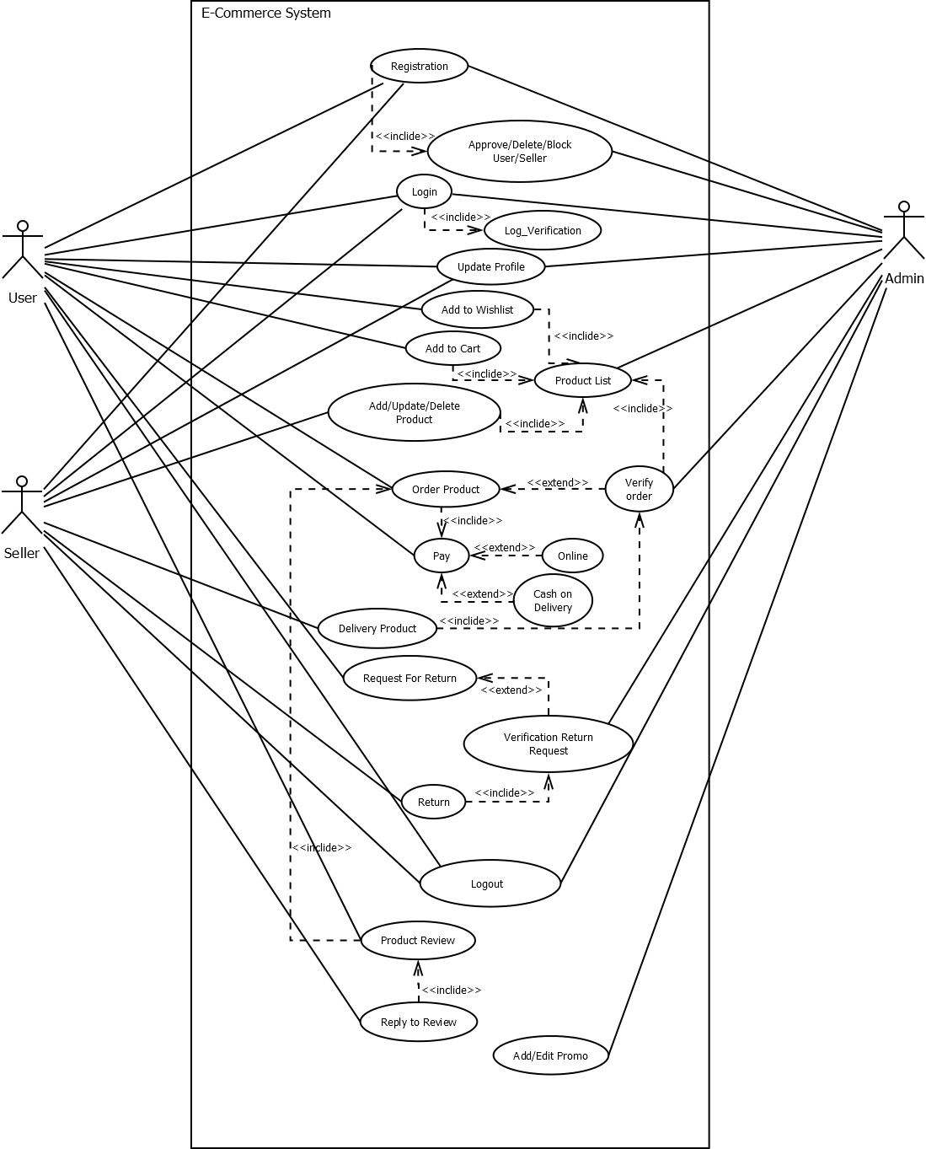

**Activity Diagram:**

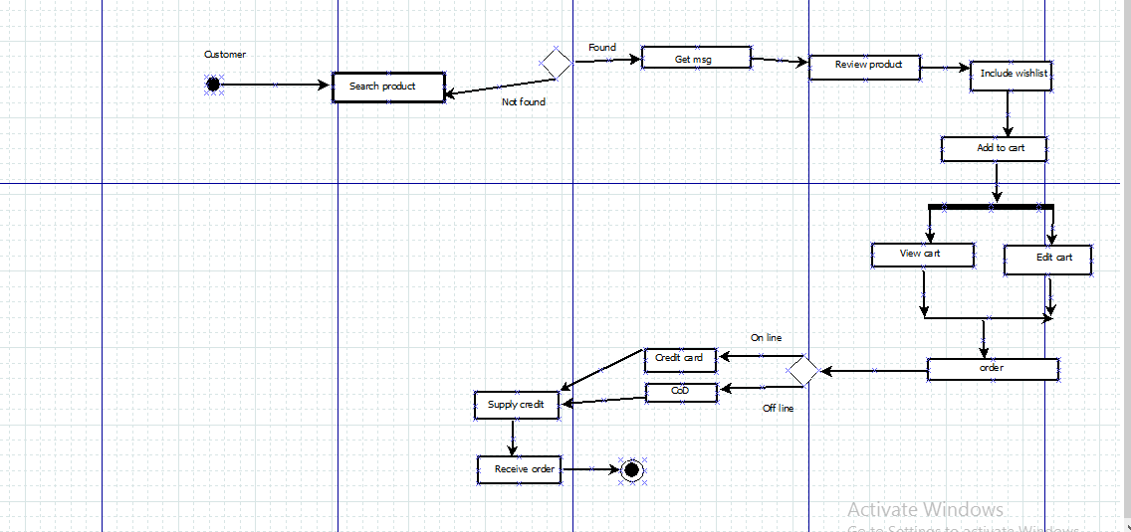

**Schema diagram:**

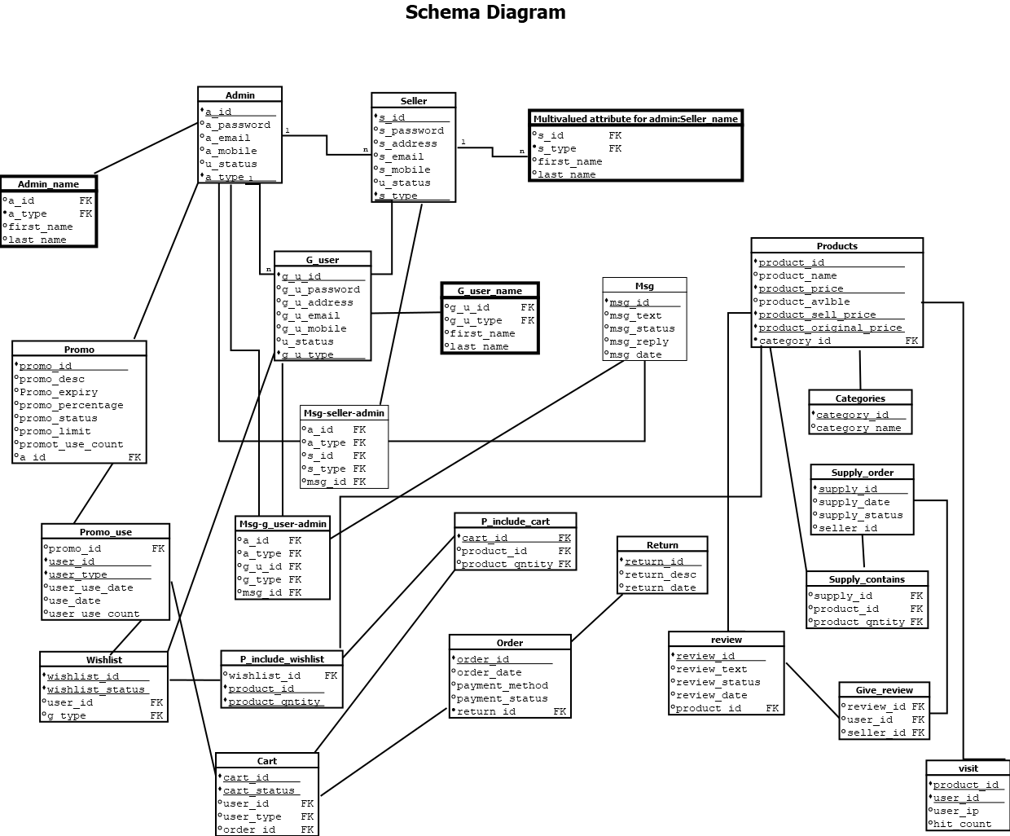

**List of attribute model :**

1. **Admin’s Attributes** :

|  |  |  |  |  |  |  |  |
| --- | --- | --- | --- | --- | --- | --- | --- |
| **Attributes** | A_id | A_password | A_address | A_email | A_mobile | U_status | A_type |
| **Data Type** | number(5) | varchar2(15) | varchar2(30) | varchar2(30) | number(11) | varchar2(30) | varchar2(30) |

1. **Seller’s Attributes:**

|  |  |  |  |  |  |  |  |
| --- | --- | --- | --- | --- | --- | --- | --- |
| **Attributes** | S_id | S_password | S_address | S_email | S_mobile | U_status | S_type |
| **Data Type** | number(5) | varchar2(30) | varchar2(30) | varchar2(30) | number(11) | varchar2(30) | varchar2(30) |

1. **G_user’s Attributes:**

|  |  |  |  |  |  |  |  |
| --- | --- | --- | --- | --- | --- | --- | --- |
| **Attributes** | Gu_id | Gu_password | Gu_address | Gu_email | Gu_mobile | u_status | Gu_type |
| **Data Type** | number(5) | varchar2(15) | varchar2(30) | varchar2(30) | number(11) | varchar2(30) | varchar2(30) |

1. **Multivalued attribute for admin:**

**Admin _name:**

|  |  |  |  |  |
| --- | --- | --- | --- | --- |
| **Attributes** | a_id | a_type | **first_name** | **Last_name** |
| **Data Type** | number(5) | varchar2(30) | varchar2(30) | varchar2(30) |

1. **Multivalued attribute for seller:**

**Seller _name:**

|  |  |  |  |  |
| --- | --- | --- | --- | --- |
| **Attributes** | S_id | S_type | **first_name** | **Last_name** |
| **Data Type** | number(5) | varchar2(30) | varchar2(30) | varchar2(30) |

1. **Multivalued attribute for g_user:**

**G_user_name:**

|  |  |  |  |  |
| --- | --- | --- | --- | --- |
| **Attributes** | Gu_id | Gu_type | **first_name** | **last_name** |
| **Data Type** | number(5) | varchar2(30) | varchar2(30) | varchar2(30) |

1. **Msg’s attributes:**

|  |  |  |  |  |  |
| --- | --- | --- | --- | --- | --- |
| **Attributes** | msg_id | msg_text | msg_status | msg_reply | msg_date |
| **Data Type** | number(5) | varchar2(30) | varchar2(30) | varchar2(30) | varchar2(10) |

1. **Msg-seller-admin attributes:**

|  |  |  |  |  |  |
| --- | --- | --- | --- | --- | --- |
| **Attributes** | a_id | a_type | S_id | S_type | msg_id |
| **Data Type** | number(5) | varchar2(30) | number(5) | varchar2(30) | number(5) |

1. **Msg-g_user-admin attributes :**

|  |  |  |  |  |  |
| --- | --- | --- | --- | --- | --- |
| **Attributes** | a_id | a_type | Gu_id | Gu_type | msg_id |
| **Data Type** | number(5) | varchar2(30) | number(5) | varchar2(30) | number(5) |

1. **Promo’s attributes :**

|  |  |  |  |  |  |  |  |  |
| --- | --- | --- | --- | --- | --- | --- | --- | --- |
| **Attributes** | Promo_id | Promo_  desc | Promo_  expiry | Promo_  percentage | Promo_  status | Promo_  limit | Promo_  **Use_count** | a_id |
| **Data Type** | Number  (5) | Varchar2  (30) | Varchar2  (30) | Number  (20) | Varchar2  (20) | Varchar2  (30) | Number  (10) | number (5) |

1. **Promo_use attributes :**

|  |  |  |  |  |  |
| --- | --- | --- | --- | --- | --- |
| **Attributes** | Promo_id | user_id | user_type | user_use_date | user_use_account |
| **Data Type** | number(5) | number(5) | varchar2(30) | number(22) | number(20) |

1. **Wishlist’s attributes:**

|  |  |  |  |  |
| --- | --- | --- | --- | --- |
| **Attributes** | wishlist_id | wishlist_status | user_id | Gu_type |
| **Data Type** | number(5) | varchar2(30) | number(5) | varchar2(30) |

**13) P_include_wishlist attribute:**

|  |  |  |  |
| --- | --- | --- | --- |
| **Attributes** | wishlist_id | product_id | product_qntity |
| **Data Type** | number(5) | number(5) | varchar2(30) |

1. **P_include_cart attributes:**

|  |  |  |  |
| --- | --- | --- | --- |
| **Attributes** | cart_id | product_id | product_qntity |
| **Data Type** | number(5) | number(5) | varchar2(30) |

1. **Cart’s attributes (updated):**

|  |  |  |  |  |  |
| --- | --- | --- | --- | --- | --- |
| **Attributes** | cart_id | cart_status | user_id | Gu_type | Order_id |
| **Data Type** | number(5) | varchar2(30) | number(5) | varchar2(30) | number(5) |

1. **Order_t attributes (updated):**

|  |  |  |  |  |  |
| --- | --- | --- | --- | --- | --- |
| **Attributes** | order_id | order_date | payment_method | payment_status | return_id |
| **Data Type** | number(5) | number(20) | varchar2(30) | varchar2(30) | number(5) |

1. **Return_t attributes:**

|  |  |  |  |
| --- | --- | --- | --- |
| **Attributes** | return_id | return_desc | return_date |
| **Data Type** | number(5) | varchar2(30) | number(20) |

1. **Product’s attributes (updated):**

|  |  |  |  |  |  |  |  |
| --- | --- | --- | --- | --- | --- | --- | --- |
| **Attributes** | product_id | product_name | product_price | product_avlble | product_sell_price | product_orginal _price | Category_id |
| **Data Type** | number(5) | varchar2(30) | varchar2(30) | varchar2(30) | number(5) | number(5) | number(5) |

1. **Categories attributes :**

|  |  |  |
| --- | --- | --- |
| **Attributes** | Category_id | Category_name |
| **Data Type** | number(5) | varchar2(30) |

1. **Supply order attributes :**

|  |  |  |  |  |
| --- | --- | --- | --- | --- |
| **Attributes** | Supply_id | Supply_date | Supply_status | S_id |
| **Data Type** | number(5) | number(10) | varchar2(30) | number(5) |

1. **Supply contains attributes:**

|  |  |  |  |
| --- | --- | --- | --- |
| **Attributes** | Supply_id | product_id | product_quntity |
| **Data Type** | number(5) | number(5) | varchar2(30) |

1. **Give _ review attribute:**

|  |  |  |  |
| --- | --- | --- | --- |
| **Attributes** | Review_id | user_id | S_id |
| **Data Type** | number(5) | number(5) | number(5) |

1. **Review attributes (update):**

|  |  |  |  |  |  |
| --- | --- | --- | --- | --- | --- |
| **Attributes** | Review_id | Review_text | Review_status | Review_date | product_id |
| **Data Type** | number(5) | varchar2(30) | varchar2(30) | number(10) | number(5) |

1. **Visit’s attributes:**

|  |  |  |  |  |
| --- | --- | --- | --- | --- |
| **Attributes** | product_id | N_user_id | user_ip | Hit_count |
| **Data Type** | number(5) | number(5) | number(5) | number(5) |

**Schema Diagram:**

**Screenshots of the table with only data type of the attributes:**

**Admin:**

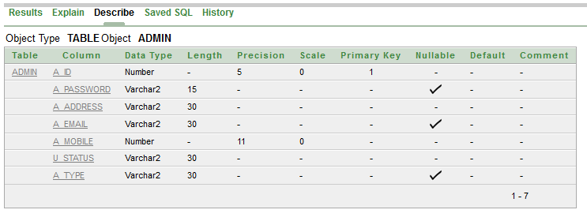

**Seller:**

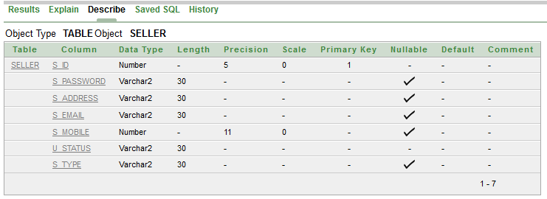

**G_user:**

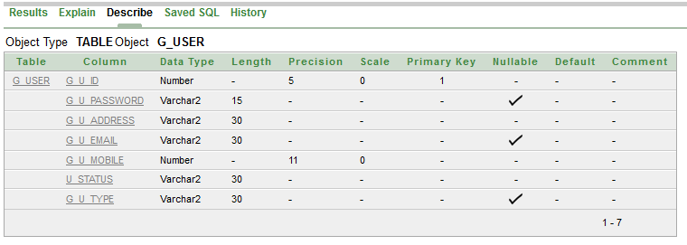

**Seller_name:**

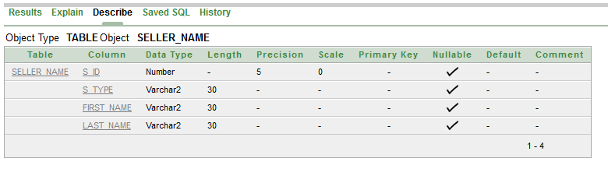

**Admin_name:**

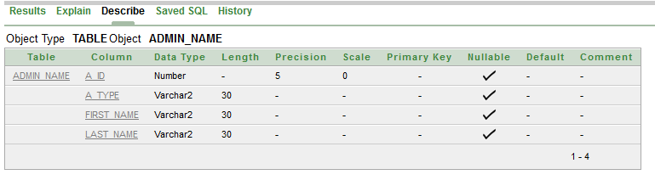

**G_user_name:**

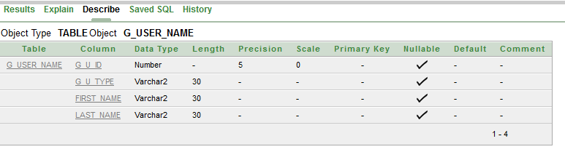

**Msg:**

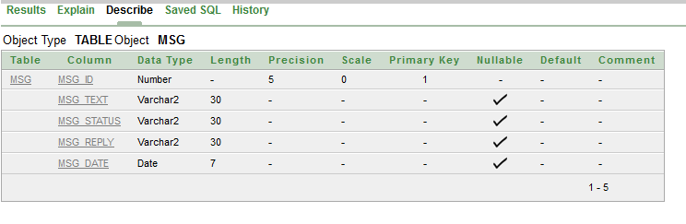

**Msg_seller_admin:**

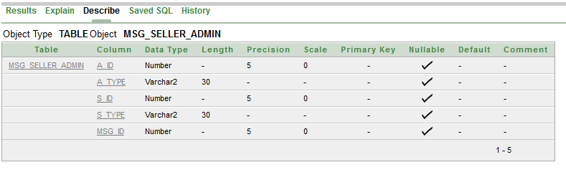

**Msg_g_user_admin:**

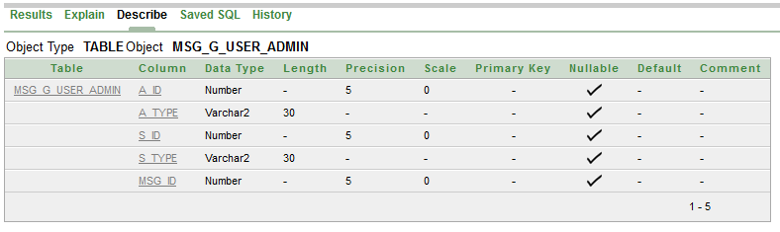

**Promo:**

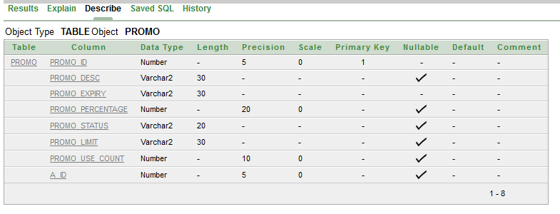

**Promo_use:**

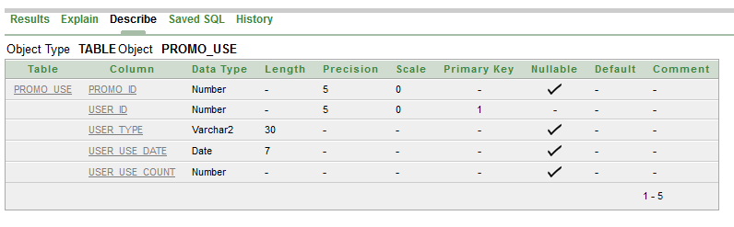

**Wishlist:**

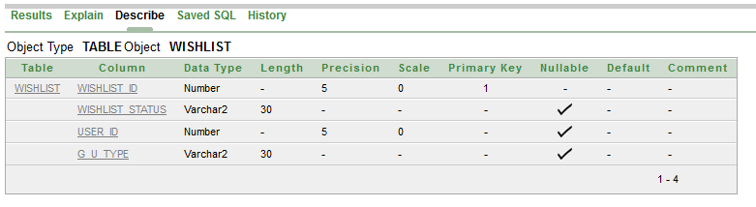

**P_include_wishlist:**

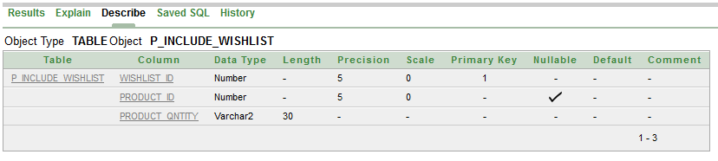

**P_include_cart:**

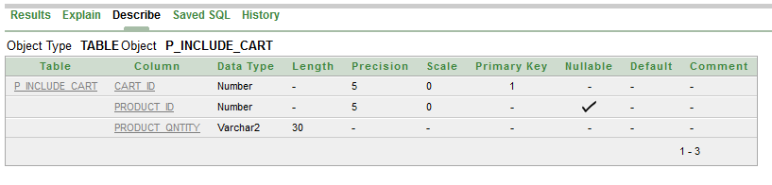

**Cart:**

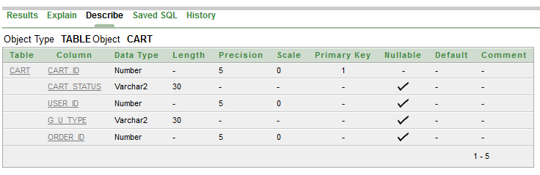

**Order_t:**

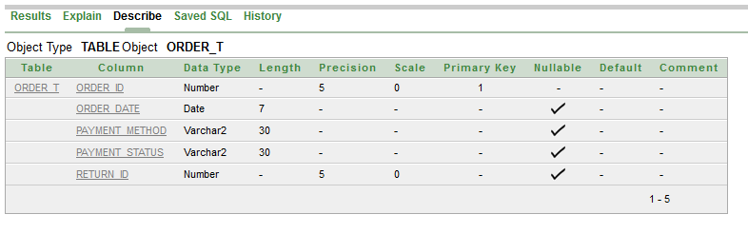

**Return_t:**

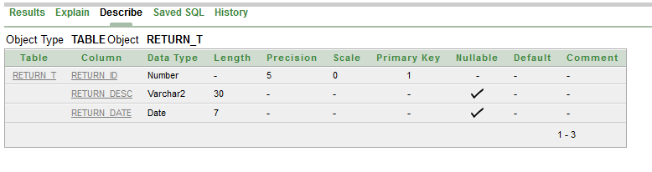

**Products:**

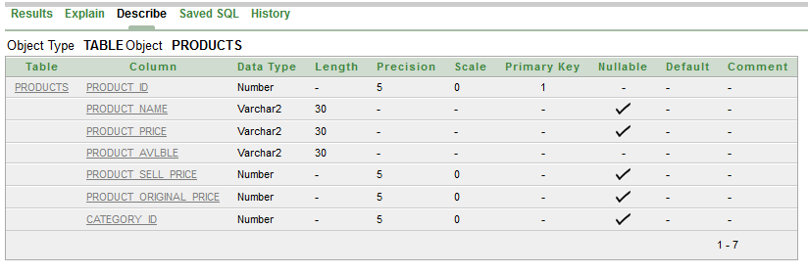

**Catagories:**

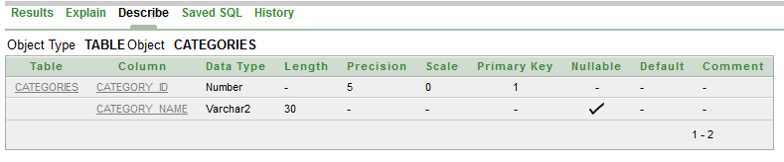

**Supply_order:**

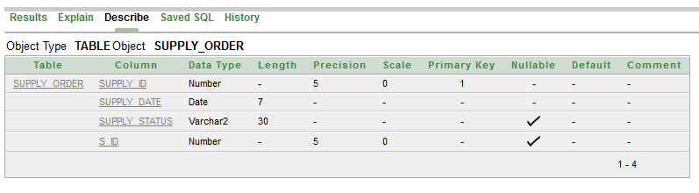

**Supply_contains:**

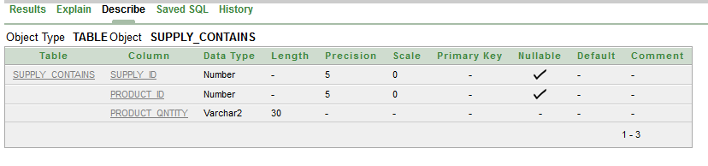

**Give_review:**

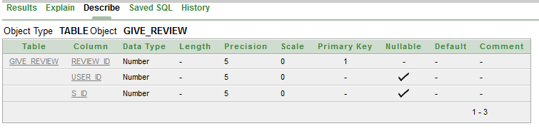

**Review:**

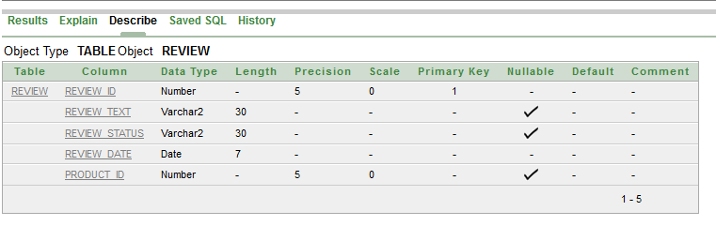

**Visit:**

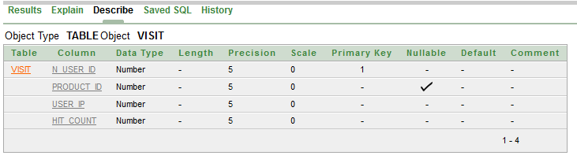

**Screenshot of the tables with sample data records**

**Admin**

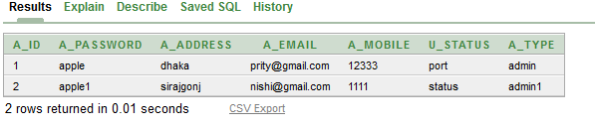

**Seller**

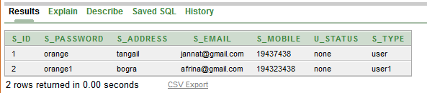

**G_user**

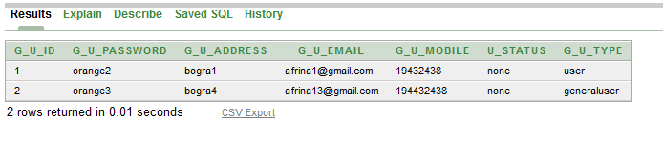

**Seller_name**

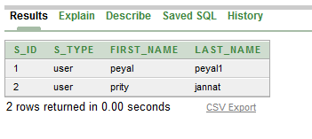

**Admin_name**

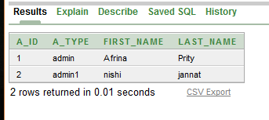

**G_user_name**

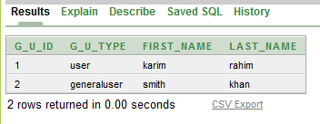

**Msg**

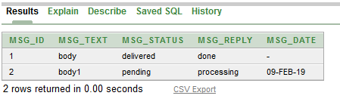

**Promo**

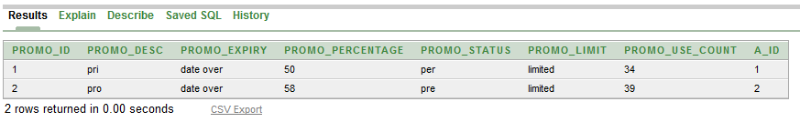

**Promo_use**

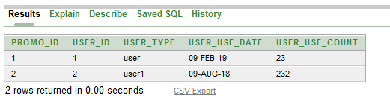

**Wishlist**

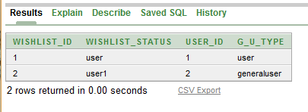

**P_include_wishlist**

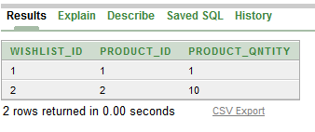

**P_include_cart**

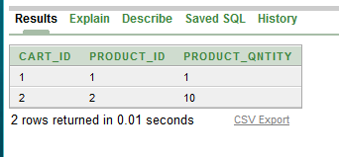

**Cart**

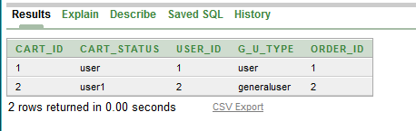

**Order_t**

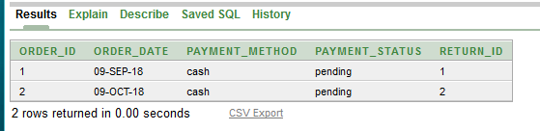

**Return_t**

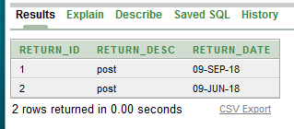

**Products**

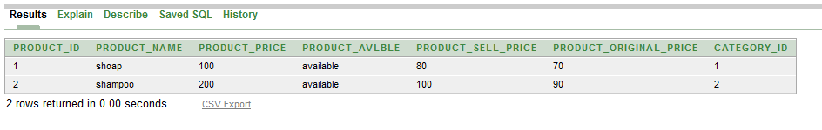

**Categories**

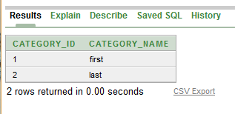

**Supply_order**

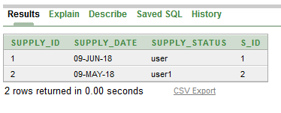

**Supply_contains**

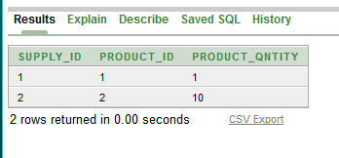

**Give_review**

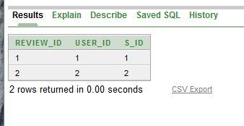

**Review**

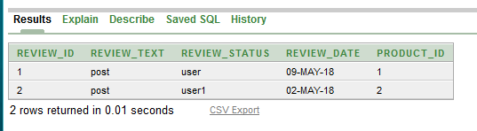

**Visit**

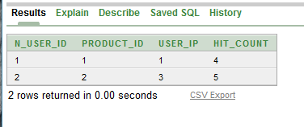

**Demonstrating some database use scenarios and SQL querie**

1.Find out seller info,prduct_id,product_price,category who sells shampoo

select Seller.s_id,Seller.s_address,Supply_order.supply_date,products.product_name,product_id,products.product_price,categories.category_name from Seller,Supply_order,products,categories where products.category_id=categories.category_id and Seller.s_id=Supply_order.s_id and product_name='shampoo'

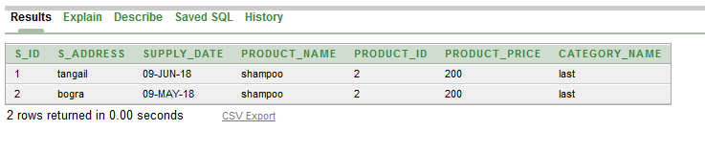

2. Display Maximum selling product product_price group by Product id

select products.product_id,max(products.product_price) from products,supply_contains where products.product_id=supply_contains.product_id group by products.product_id

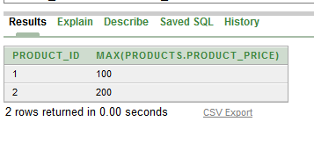

3. Show order list and cart id where who’s g_id=1

select order_date,payment_method,payment_status,cart_status,cart_id from order_t,cart,g_user where order_t.order_id=cart.cart_id and g_user.g_u_type=cart.g_u_type and g_u_id='1'

